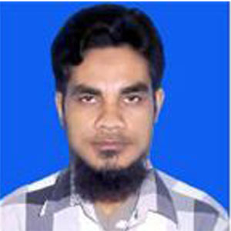
RESUME
OF
MD. SAIFUL ISLAM
Cell : 01611-201238
Career Objective:
I wish to get a job in any sector where I would like to implement my enthusiasm, academic skills and experience, ability to communicate innovative ideas, acceptability of challenging work in such an enthusiastic team oriented organization, where I can utilize my knowledge, sincerity, curiosity, liability, honesty, perform quality work and can further develop the future opportunities in the completive sector.

Masters of Social Science
University : Govt. Gurudayal College, kishoreganj.
Institution : National University
Subject : Political Science
Year of Passing : 2017
Result : 2.66

Bachelor of Social Science (Degree pass)
University : Govt. Gurudayal College, kishoreganj.
Institution : National University
Subject : B.S.S
Year of Passing : 2014
Result : 2nd Division

Higher Secondary Certificate (H.S.C)
Institution : Technical School & College, Kishoreganj.
Subject : Science
Year of Passing : 2010
Board : Dhaka
Result : GPA- 4.00

Secondary School Certificate (S.S.C)
Institution : Technical School & College, Kishoreganj.
Subject : Science
Year of Passing : 2008
Board : Dhaka
Result : GPA- 3.73

Computer Literacy:
Basic knowledge of Computer system unit, Microsoft word, MS Access,
Power Point, HTML, Adobe Photoshop, Internet browsing, & Multimedia.

Personal Attributes:
- Self-motivated, Aggressive and good Communication Skill.
- Hard working and able to work under pressure.
- Willing to learn new Technologies and projects.
- A good team leader.
- Looking for full time entry label job.
Special Interest:
- Hard Work
- Traveling new places.
- Communicating with common people.
Personal Profile:
Name : Md. Saiful Islam
Father’s Name : Md. Abu Bakkar
Mother’s Name : Mst. Mahamuda Akhter
Date of Birth : 01-07-1991
Permanent Address : Vill: Basurdia, P.O: Swalpa Maria
P.S: Kishoreganj, Dist: Kishoreganj.
Present Address : Vill: Basurdia, P.O: Swalpa Maria
P.S: Kishoreganj, Dist: Kishoreganj.
Nationality : Bangladeshi
National ID No : 3733141549
Religion : Islam
Marital Status : Unmarried
Mobile No. : 01611-201238
Job Experiences :
- Work as a Delivery incharge M/S Rofiq Book House Pakundia, Kishoreganj .From 2012 to 2013.
- Work as a Asst. Accounts Auto Ricksha Multiperpes Ltd Basurdia, Kishoreganj. From 2014-2016.
- Work as a Eassy Plastics Industries Accounts Still now, Amlitala, Kishoreganj

I hereby declare that the above statements are true to the best of my knowledge.

Signature


